Architecture and planning of the website

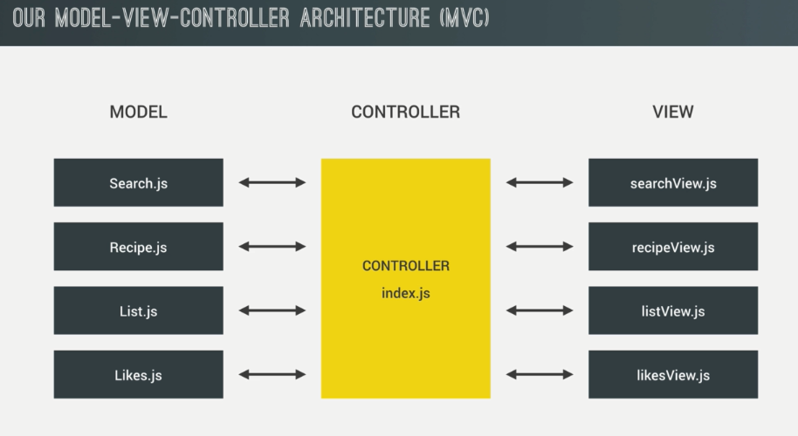

Exporting fuctions and variable using ES6 from one mudule to another

export const add = (a, b) => a + b;

export const multiply = (a,b) => a\*b;

export const ID = 23;

importing multiple variables and functions from another module

import {add, multiply, ID} from './views/SearchView.js';

console.log(add(2,3));

console.log(multiply(5,4));

console.log(ID);

I f you want to import with aspecific name

import {add as a, multiply as b, ID} from './views/SearchView.js';

if u need to imoport module an object

import \* as SearchView from './views/SearchView'

console.log(SearchView.add(2,3));

console.log(SearchView.multiply(5,4));

console.log(SearchView.ID);

Making the API calls

First you need an API key.

an API key actually is and so let me explain it to you. So an API key it's like a password that's given to each user. It's like a unique ID that each user can use in order to make requests and so that the API can track how many requests you make per day.

Anything that we take from fetch or import is an http request.

fetch function wont work in theolder browser.

So we can use instead http request library called axios.

For error handling, we can use try catch:

try{

const res = await axios(`${proxy}https://www.food2fork.com/api/search?key=${key}&q=${query}`);

const recipes = res.data.recipes;

console.log(recipes);

}

catch(error){

alert(error);

}

Axios will pass the error parameter which in turn to be passed too catch method.

BUILDING Search Model

Exporting a class in es6

When we deinfe a class in JS, first we need to define constructor method, which is a method that's always called as soon as we create a new object based on the class.

Usually you define method like thisso just the method name and the parameters nbut in case that it's an async function and it works just the same as it works with regular functions, so we just used async keyword and so we say that this is an asynchronous method of this class.

Class is simply like a function construbtor

import axios from 'axios';

export default class Search{

constructor(*query*){

*this*.query = query;

}

async getResults(){

const proxy = `https://cors-anywhere.herokuapp.com/`;

const key = 'dd010099bff9146b81f1716512a905e6';

try{

const res = await axios(`${proxy}https://www.food2fork.com/api/search?key=${key}&q=${*this*.query}`);

*this*.result = res.data.recipes;

console.log(*this*.result);

console.log(*this*)

}

catch(error){

alert(error);

}

}

}

Here method getResults is a property of the class.

Importing the class from other module

import Search from './models/Search';

if we simply do:

console.log(search);

only query will be printed as the function is not called.

console.log(search);

if we call the function like this from the index.js module the whole recipe information will be printed.

State

So think about what is the like the current search query?

Or what's the current recipe?

Or how many servings are currently being calculated?

And what's currently in the shopping list?

So all few things in one given moment are the state. So all these data in the current state

in a current moment of our app,

for this we define an object in the main controller called state. And each time we reload the app, this object will be empty.

The variable that we pass to event listners are called event handlers.